Name:………………………………………………..…. Date:………………………………………………………
Crystal chemistry

Growing crystals
All crystals grow from something! But how do they start and how can large crystals form? Here is an experiment to find out more about crystal growth.
Big or small?
This experiment shows what makes crystals large or small.
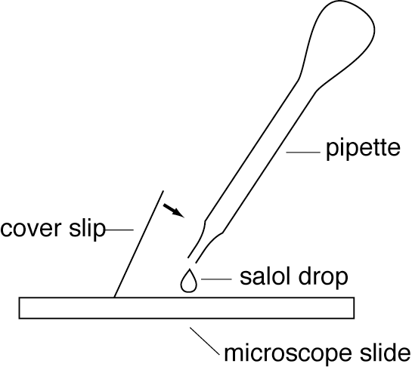

What you need
- 2 microscope slides – one cooled in a freezer and another heated in hot water
- 2 cover slips
- Melted salol
- Pipette
- Microscope or hand-lens
- Paper towel
- Stopwatch
- Eye protection

Experiment: big or small?

What you do
1. Take a COLD microscope slide. If needed, dry it using the paper towel.
2. Put one drop of melted salol on to the slide.
3. Place a cover slip over the drop – to do this, see diagram above.
4. Start the stopwatch.
5. Look at the slide under a microscope or hand-lens.
6. Note the time when crystals first appear. Keep the stopwatch going.
7. Note the time when crystallisation seems to stop.
8. Reset the stopwatch.
9. Repeat all these steps with a HOT microscope slide.
10. Look at both slides carefully and make as many observations as possible.
Safety
Wear eye protection.

Write down
1. The time when the first crystals appeared on both slides.
Cold: ……………………………………………………………………………………………………………….
Hot: ……………………………………………………………………………………………………………….
continued on next page



Crystal chemistry
continued from previous page

2. The time when the first crystals appeared on both slides.
Cold: ……………………………………………………………………………………………………………….
Hot: ……………………………………………………………………………………………………………….
3. What differences there are between the crystals on the two slides.
……………………………………………………………………………………………………………….……………………………………………………………………………………………………………….……………………………………………………………………………………………………………….……………………………………………………………………………………………………………….
Questions
1. Which slide had the biggest crystals? Explain why.
……………………………………………………………………………………………………………….……………………………………………………………………………………………………………….……………………………………………………………………………………………………………….……………………………………………………………………………………………………………….
2. What happens to the particles when crystals form?
……………………………………………………………………………………………………………….……………………………………………………………………………………………………………….……………………………………………………………………………………………………………….……………………………………………………………………………………………………………….
3. The same process happens in rocks when magma cools. Find out the names of rocks formed by quick and slow cooling, and describe their crystal size.
……………………………………………………………………………………………………………….……………………………………………………………………………………………………………….……………………………………………………………………………………………………………….……………………………………………………………………………………………………………….……………………………………………………………………………………………………………….……………………………………………………………………………………………………………….……………………………………………………………………………………………………………….……………………………………………………………………………………………………………….

